Updating List Options

Roles and Permissions: IA Admin / Client Admin / Genii

On the app go to Campaigns Management

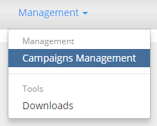

.

And then to the Overview of the campaign you will be updating



Select Campaign Form Wizard on the Overview of Campaign page

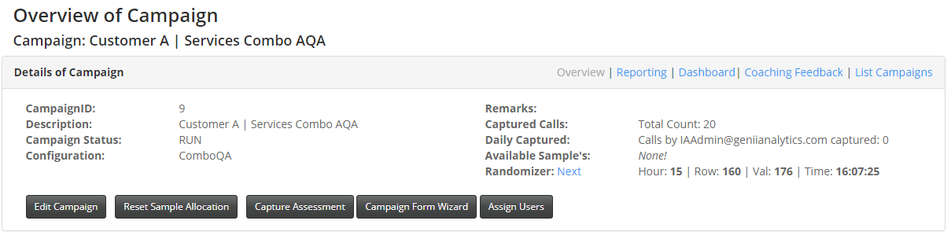

Here you will see which lists are available for update.

A Tag indicates that the wording ‘Mandatory Entry’ should be included in your list as the first entry, to ensure that the selection will be made, and validation will be performed.

The tick indicates that the list is viewable on this form.

The  cross indicates that the list is not enabled for viewing on this form.

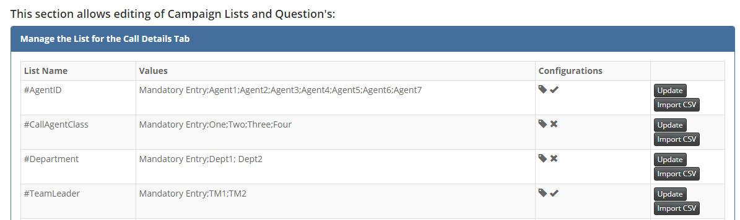

Copy the data in the Values column to excel

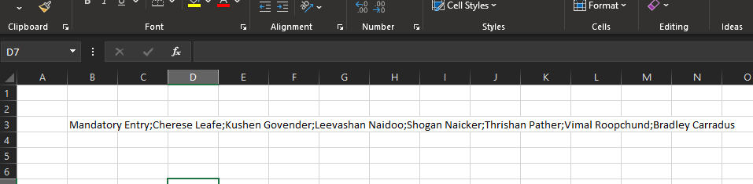

This data is currently in a single cell.

To make it a list select the cell (B3 in the eg).

From you excel menu select Data and Text to Columns

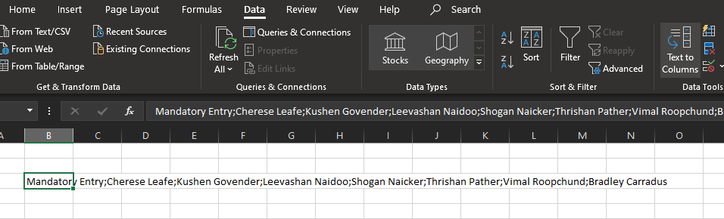

The following window will show

Select Delimited on Step 1

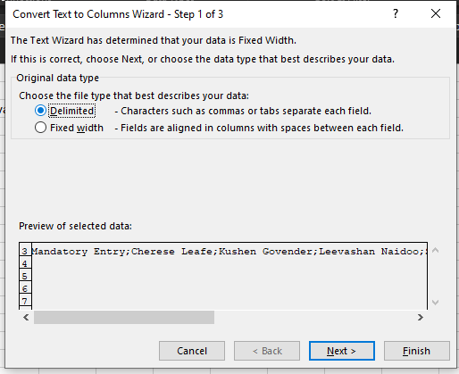

Select Semicolon and Finish on Step 2

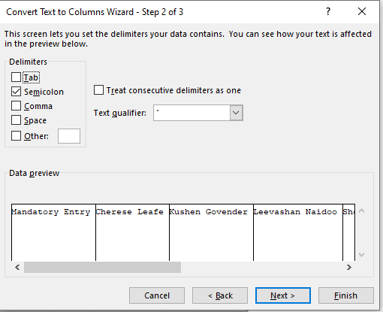

This will put the names into individual cells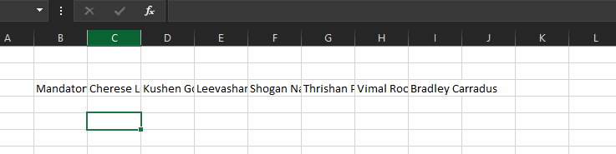

Now copy and transpose (paste) so that the list is in one column.

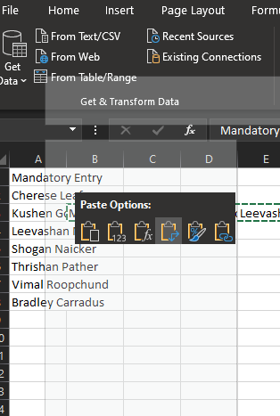

Prepare new names to be added as follows in excel:

1. Manage list as First Name, space, Last Name
2. Trim Names to ensure that there are no additional spaces before or after the names.
3. Proper Names to ensure that the names are in proper case.
4. Ensure that the spelling of each name is correct.
5. Ensure that there are none of the following special characters – ( : ; , )

Add new names to existing list

1. Alphabetise list. (Sort)
2. Save Team Leader and Agent list as separate CSV files with the headings #TeamLeader or #AgentID respectively.
3. The first entry should always be ‘Mandatory Entry’.
4. Save file in appropriate location.
5. Example Below:

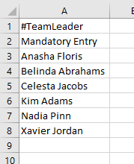

Go back to the Form Wizard on the app.



Select Import CSV on the list you wish to update.

The following pop-up screen will appear.

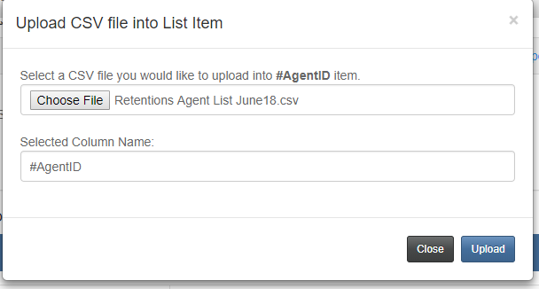

Select Choose File

Browse to the correct file to upload and select Upload.

This action will replace any data that may occupy this list.

You will get a validation message.

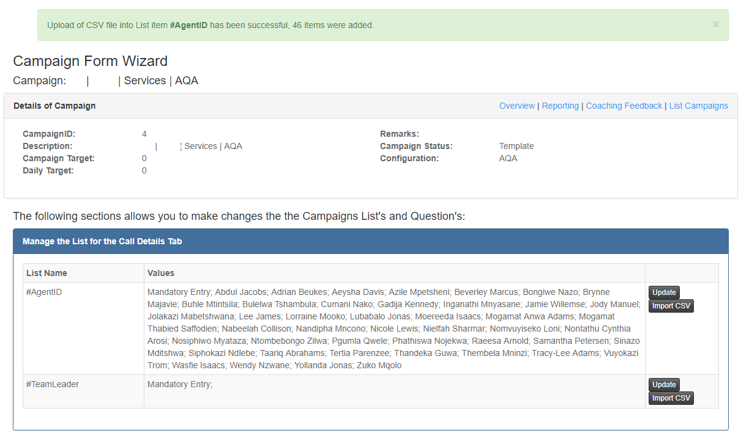

To make individual changes you can select Update to amend the list

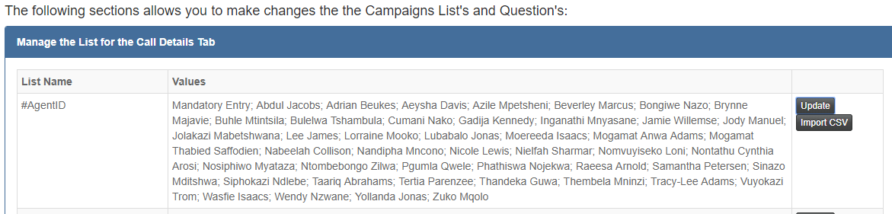

The following pop-up screen will appear, and you can make changes to your list

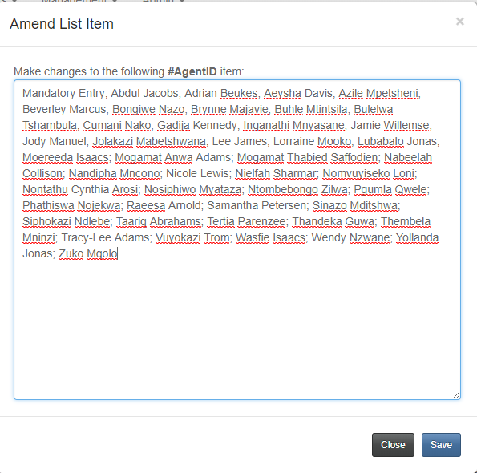

Select Save once complete with this option.

*NOTE: These entry boxes will only accommodate 8000 characters.*

*If your list grows to beyond this limitation, please contact*

*appsupport@geniianalytics.com*